Merry Christmas

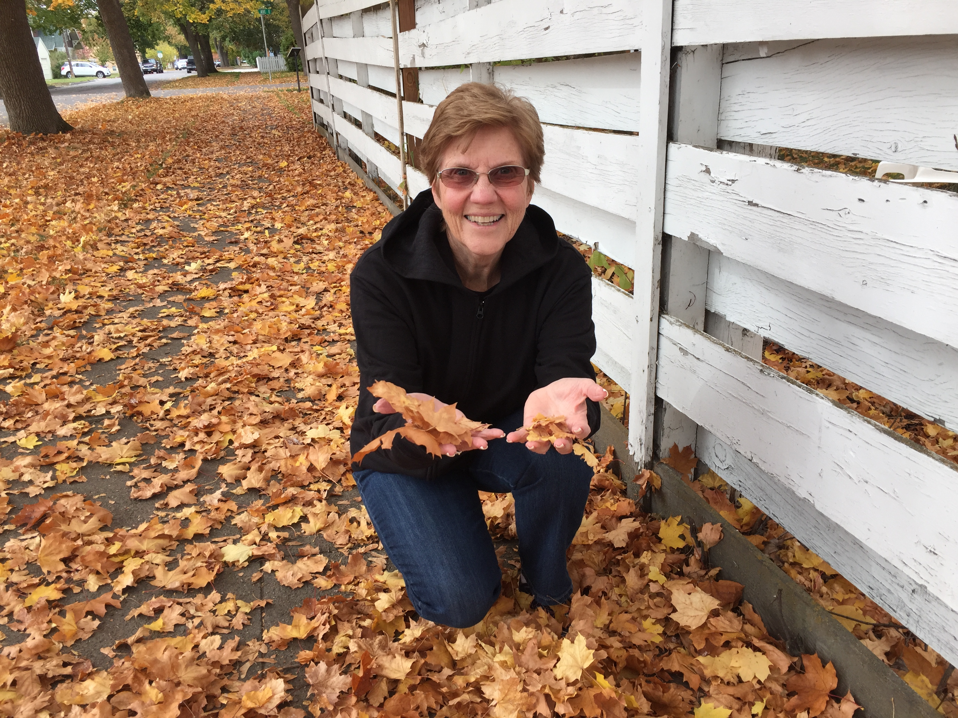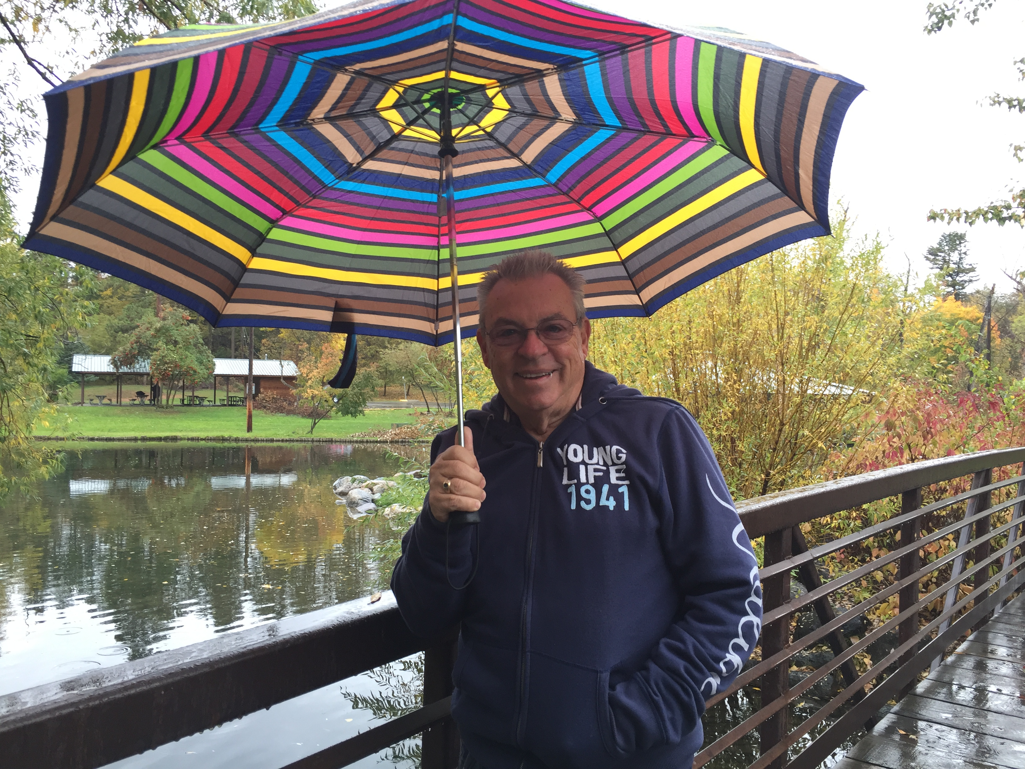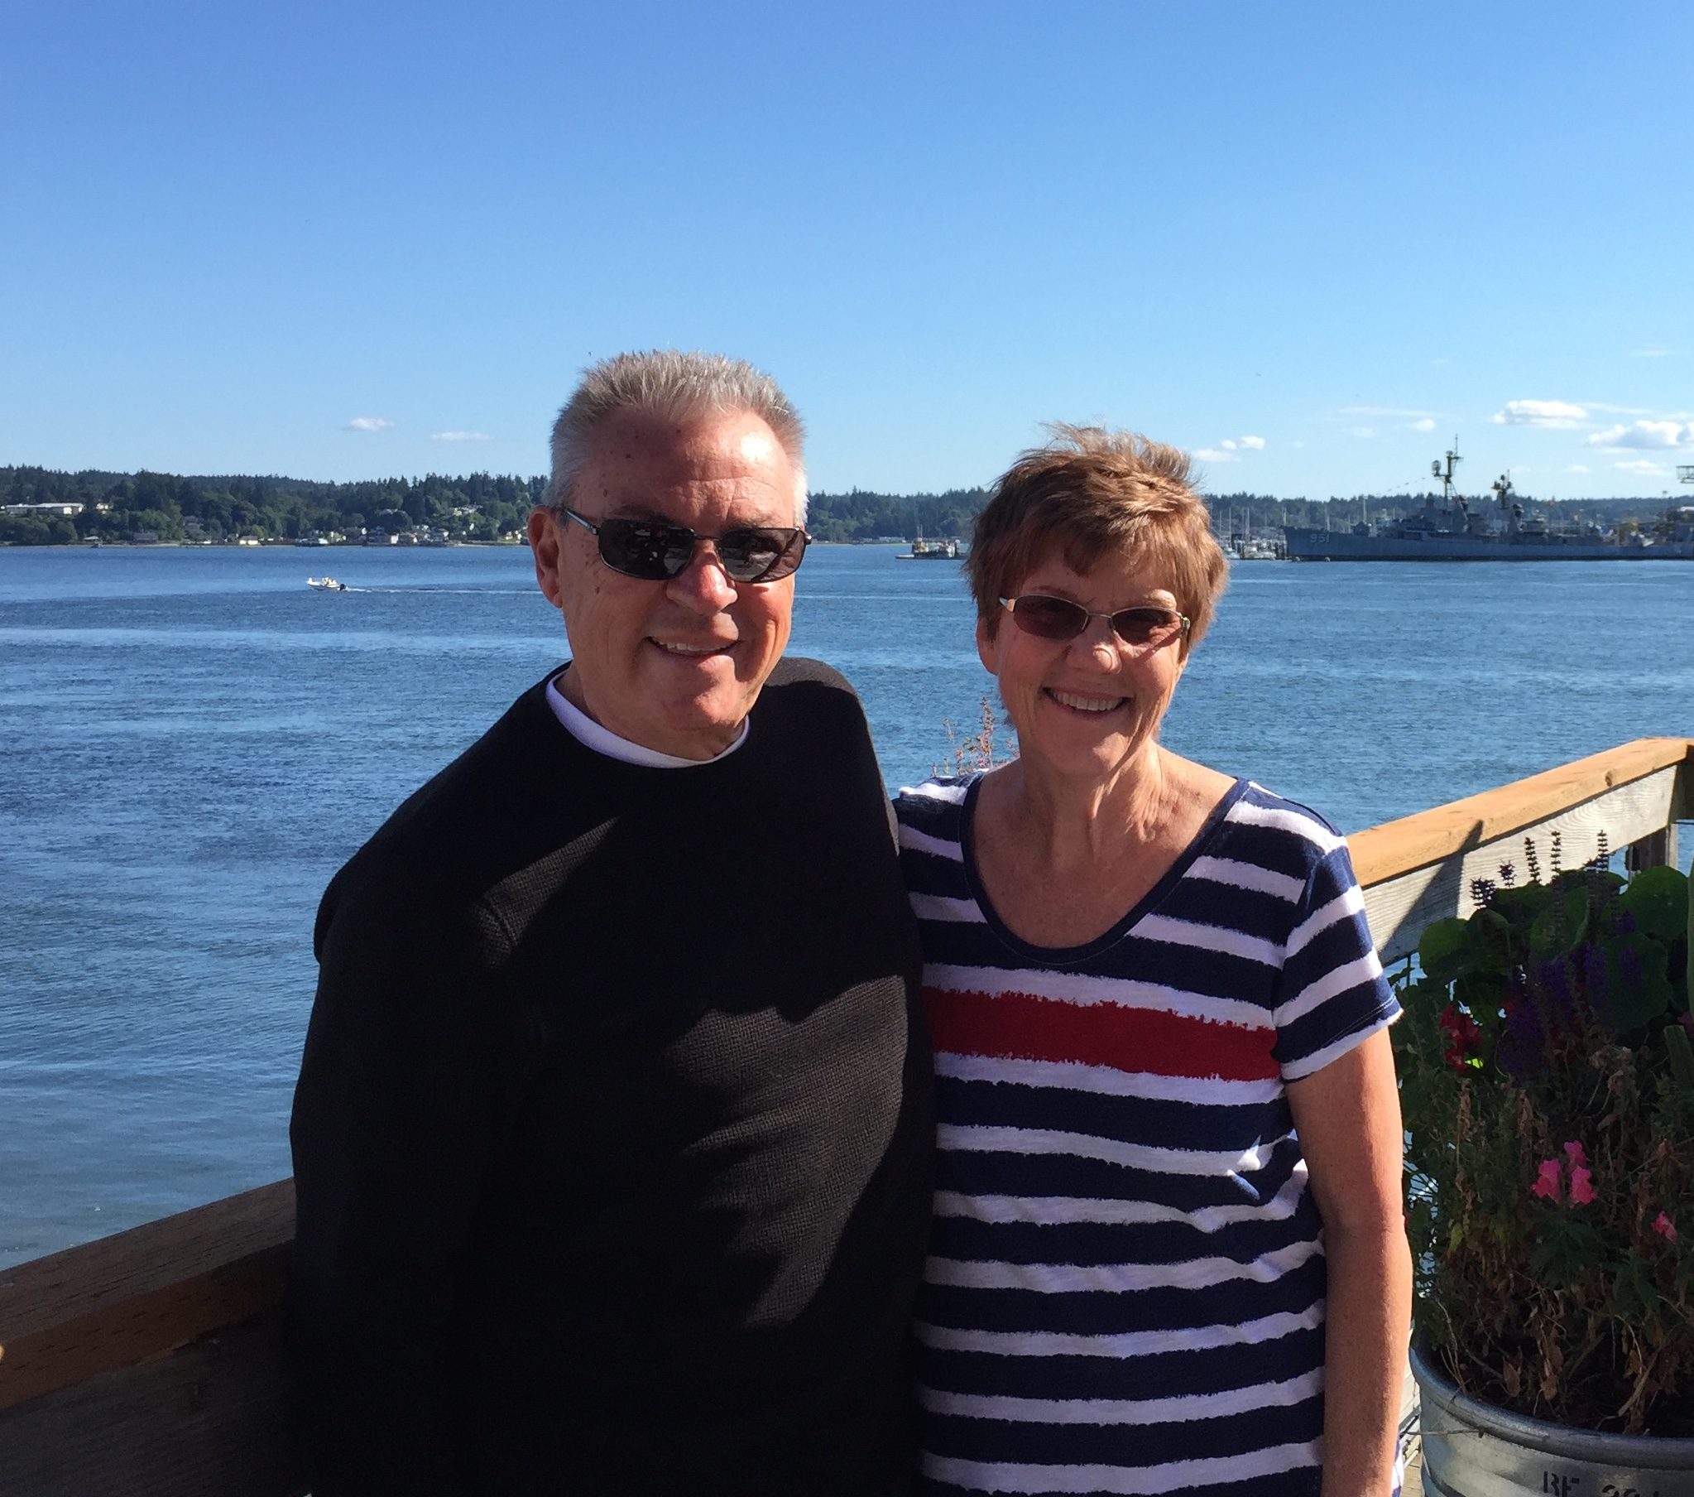

After a twenty-eight year absence, Paul and Joanie are back in Coeur d’ Alene, Idaho!

It was our home for ten years back when both boys were still home and we knew nothing about their colleges, marriages and the glorious reality of grandchildren!

God has been exceptionally good to us through the years of ministry and we are grateful, but a large part of the satisfaction of ministering to others is the ‘others’ we ministered to and alongside of. We have been blessed with incredible friends and the memories they have provided. We value our friends like rare and precious gemstones in our lives.

We continue the work of Fresh Heart Ministries and the assignments that God gives us in fulfilling that calling. We write, visit, counsel, pray, teach and love people with all our hearts.

Wes and family live in the Portland area … Dave and his family reside in Southern California. Between them we have been blessed and invigorated by the grandkids that have added such joy and excitement.

We live in one of God’s most spectacular places and would love to see you if you come our way.

3737 N. Player Drive Coeur d’ Alene, ID 83815 425 923 9000

# December 12, 2016

*From Paul and Joanie Walterman*

***There is nothing like the Christmas season to rekindle love in our hearts and refresh memories of times spent with people we love. Thanks for family and friends and for a Savior who put us all together.***